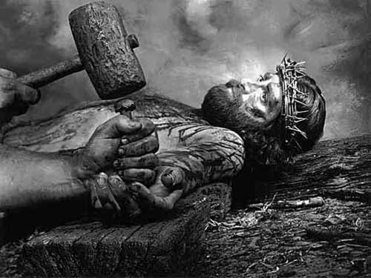
Love Shines at Calvary

Christ was all anguish that I might be all joy,
cast off that I might be brought in,
crucified as an enemy that I might be welcomed as a friend,
surrendered to hell's worst that I might attain heaven's best,
stripped that I might be clothed,
wounded that I might be healed,
athirst that I might drink,
tormented that I might be comforted,
made a shame that I might inherit glory,
entered darkness that I might have eternal light.

My Savior wept that all tears might be wiped from my eyes,
groaned that I might have endless song,
endured all pain that I might have unfading health,
bore a thorny crown that I might have a glory-diadem,
bowed his head that I might uplift mine,
experienced reproach that I might receive welcome,
closed his eyes in death that I might gaze on unclouded brightness,
expired that I might forever live.

Love shines at Calvary!

- The Valley of Vision, p. 42.

